Week 3 – 1:

--Decision Making and Branching – if, if…else and nested if…else, if…else if, Switch-case

ROLL NO.:241501164

Name: Ramana.R

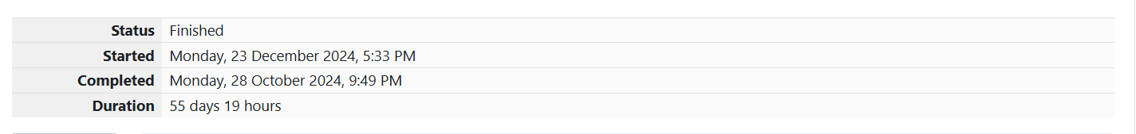

**Q1)** Write a program to read two integer values and print true if both the numbers end with

the same digit, otherwise print false.

Example: If 698 and 768 are given, program should print true as they both end with 8.

**Sample Input 1**

25 53

**Sample Output 1**

false

**Sample Input 2**

27 77

**Sample Output 2**

true

**Code:**

OUTPUT:

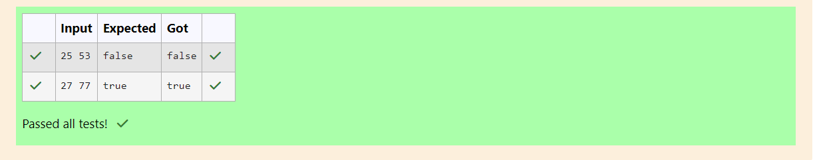

**Q2**) In this challenge, we're getting started with conditional statements.

**Task**

Given an integer, n, perform the following conditional actions:

• If n is odd, print Weird

• If n is even and in the inclusive range of 2 to 5, print Not Weird

• If n is even and in the inclusive range of 6 to 20, print Weird

• If n is even and greater than 20, print Not Weird

Complete the stub code provided in your editor to print whether or not n is weird.

**Input Format**

A single line containing a positive integer, n.

**Constraints**

• 1 < n < 100

**Output Format**

Print Weird if the number is weird; otherwise, print Not Weird.

**Sample Input 0**

3

**Sample Output 0**

Weird

**Sample Input 1**

24

**Sample Output 1**

Not Weird

**Code:**

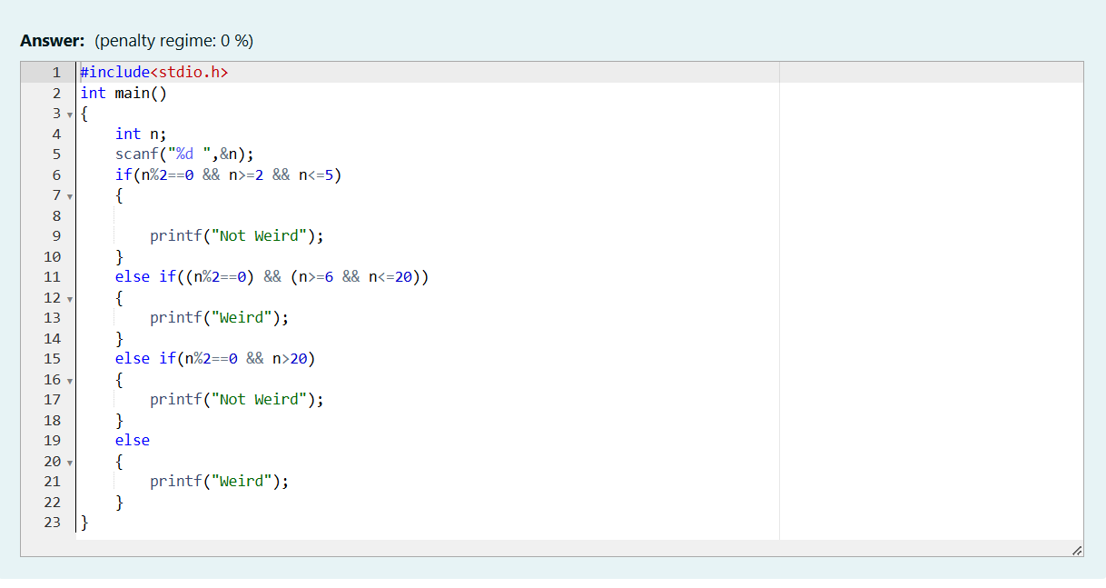

OUTPUT:

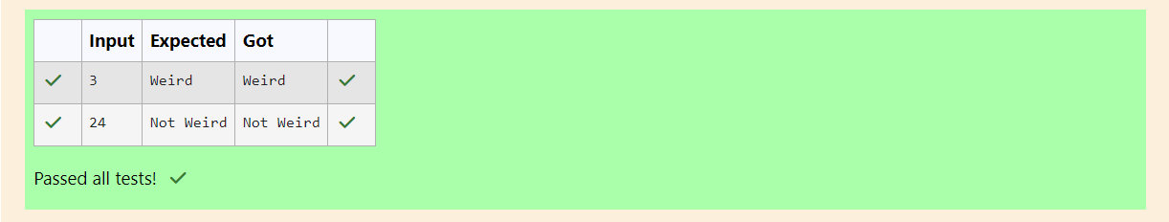

**Q3)** Three numbers form a Pythagorean triple if the sum of squares of two numbers is equal to

the square of the third.

For example, 3, 5 and 4 form a Pythagorean triple, since 3*3 + 4*4 = 25 = 5*5

You are given three integers, a, b, and c. They need not be given in increasing order. If

they form a Pythagorean triple, then print "yes", otherwise, print "no". Please note that the

output message is in small letters.

**Sample Input 1**

3

5

4

**Sample Output 1**

yes

**Sample Input 2**

5

8

2

**Sample Output 2**

no

**Code:**

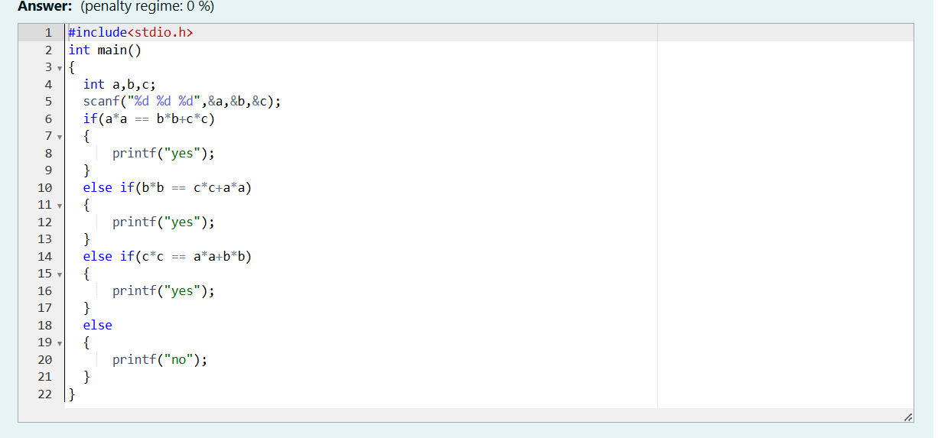

OUTPUT:

